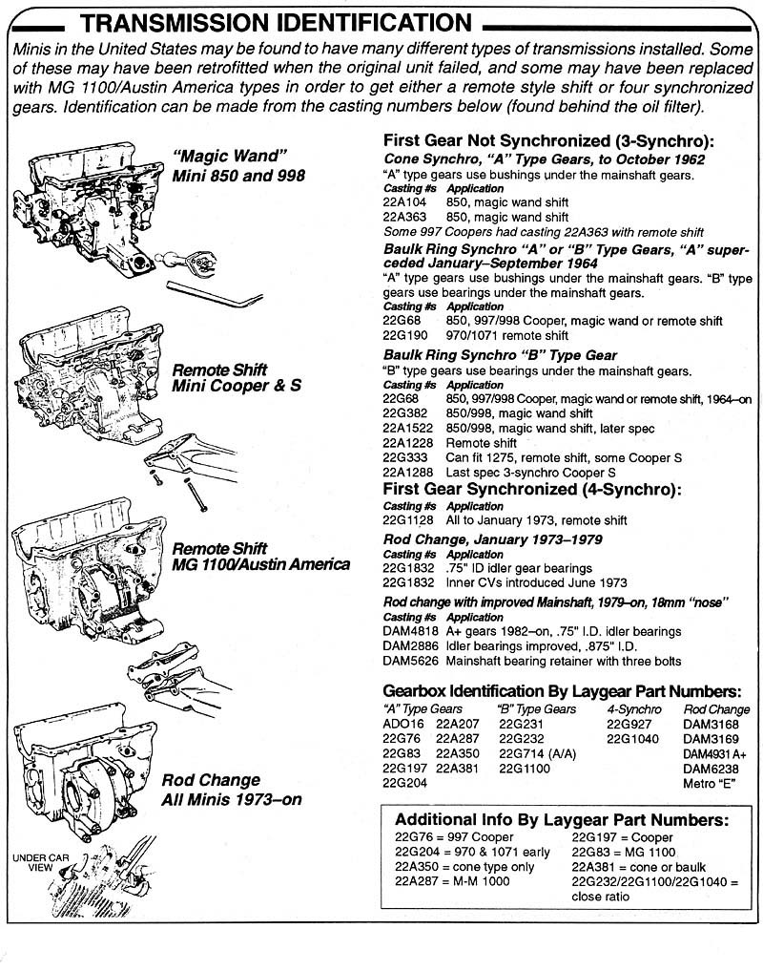
External Gearbox Identification
Numbers are found on casing below oil filter area
Mini 850 style with gearlever at firewall
Casing numbers for early brass synchro cone 22A104, 22A363
Casing numbers for later baulk ring 3 SYN 22G68,22A1288,22G382
Mini Deluxe and Mini Cooper 3 Synchro with alloy extension housing
Casing numbers Cast In . 22A1288, 22A1522, 22G190, 22G333, 22G68
The Morris 1100 sedan had a similar gearbox with the extension housing
bolted to the case with a rubber sandwich plate
Mini K and Cooper S mk11 All synchro Remote (extension) housing
Casing Numbers 22G1128, 22G846
Rod Change All (4) Synchro 2 Rods for Gearshift 1974 on
Usually Pot joint inner universals
Casing number for small idler bearing system DAM3220, 22G1832
Casings with larger idler bearings DAM2886,DAM4818,DAM5626 all are 78 on

